**Project 2 - FlyAway (An Airline Booking Portal)**

**Project and developer details**

The Project is developed by Rishabh Dixit

The all code of project is hosted on GitHub: - <https://github.com/dixitrishabh/Phase2Project_FlyAway>

**Sprints planned and the tasks achieved in them**

Creating a document and file structure of the project.

Firstly, I create a Git repo and do Git Clone.

Then create a Dynamic web project which contains java files, jsp files and servlets file.

After completing all code, I have performed different test case on this project.

At last, I push all correct to GitHub.

**Algorithms and flowcharts of the application Core concepts used in the project**

HashMap, Exception Handling, Searching, Servlets, Collections Frameworks, MySQL Connector, JSP, HTML, CSS

**Project Details: -**

Create a Dynamic web project in Eclipse

Creating packages like

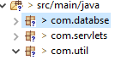

Create a structure

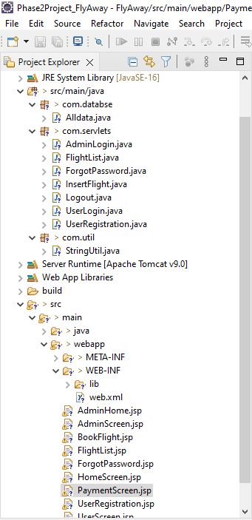

**Some Important Code Snippets –**

**Creating a connection with database and search available flights**

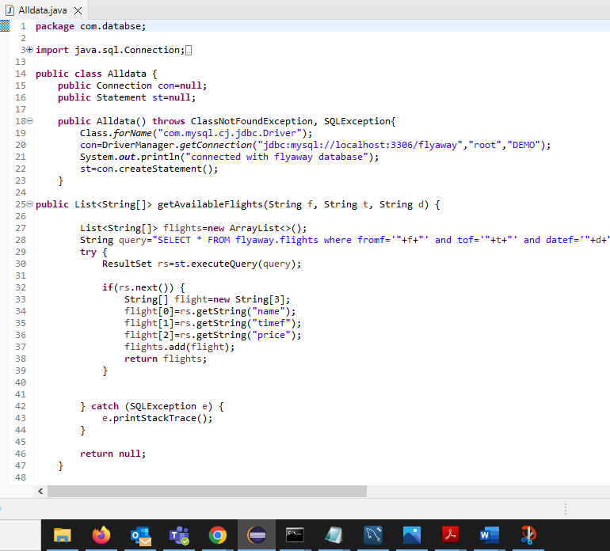

**Insert a user and check user**

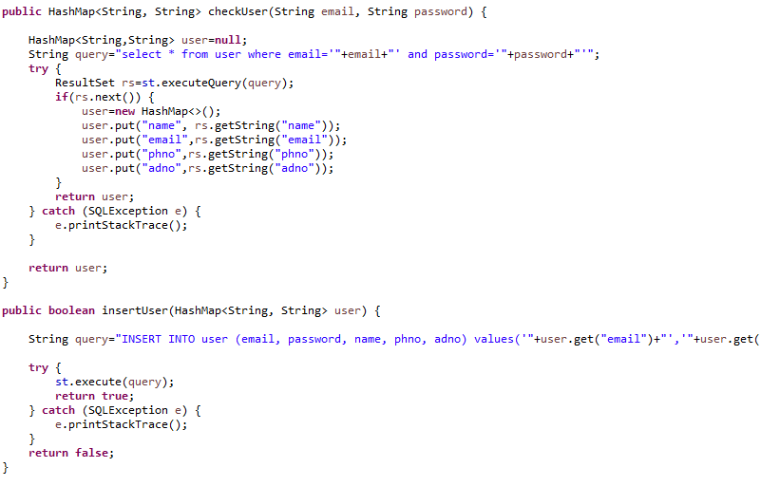

**Check admin ,change password and insert flight**

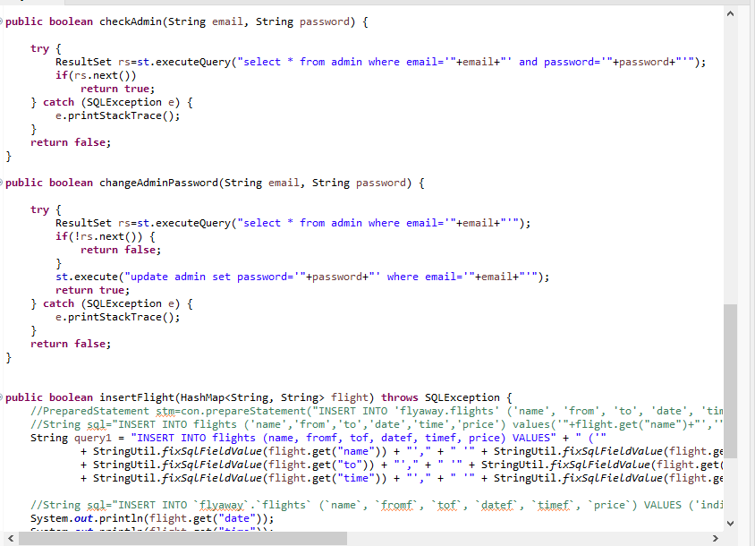

**Home screen Code**

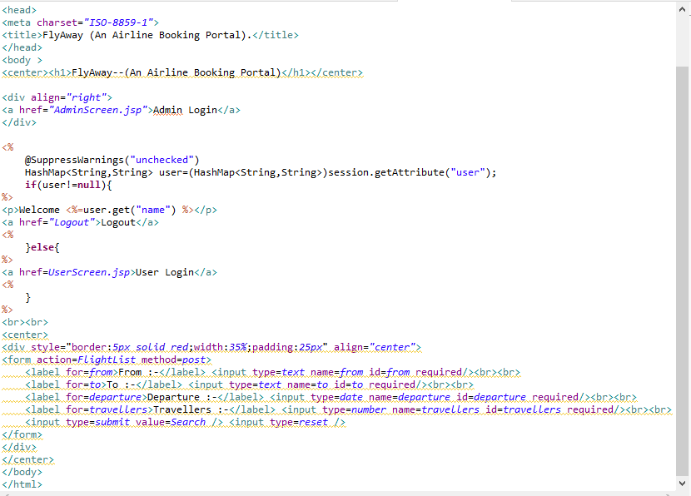

**User Registration Code**

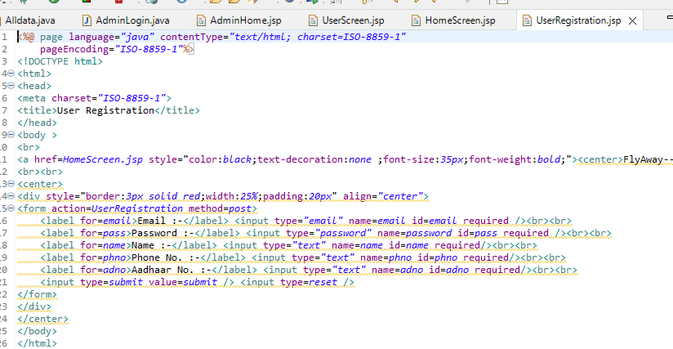

**Payment Screen Code**

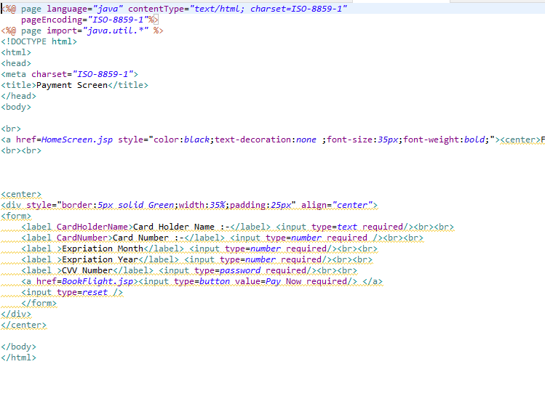

**Flight List Code**

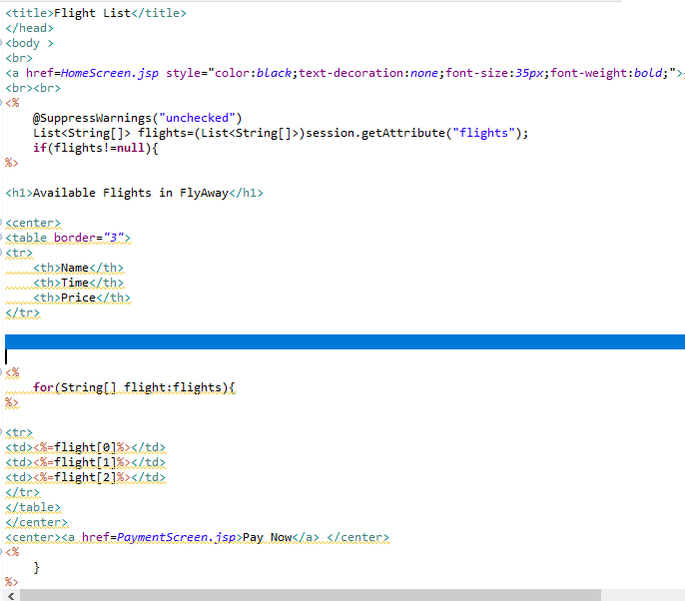

**Logout code**

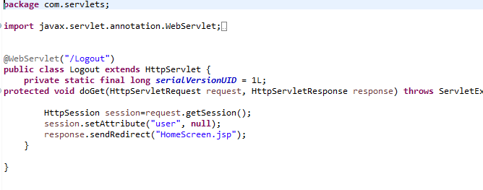

**Flyaway DB tables**

**GitHub Repo link -:** <https://github.com/dixitrishabh/Phase2Project_FlyAway>

**Your conclusion on enhancing the application and defining the USPs (Unique Selling Points):**

A website with simple user interface and user experience.

Have admin portal also from which admin can add more flights for users.

The website also contains user portal where user can search & book flight for travel.

**Some USPs –**

The application works very smoothly while taking inputs from the user.

The user can login and register easily.

The user can search flights for travel.

The website contains a dummy payment screen for payment.

The website contains admin portal where admin can login and can add more flights.

The website also contains some validations in login, register form etc.